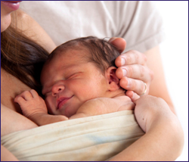

What is it?
Kangaroo care, also known as skin-to-skin contact, is a form of developmental care that involves placing a newborn infant directly on a parent’s bare chest so that there is direct skin contact between parent and baby. It is a great way for parents and baby to bond in the stressful environment of the Neonatal Intensive Care Unit.
Benefits for Baby
- Regulate heart rate, breathing, and temperature
- Improve head circumference growth and weight gain
- Stabilize organ function
- Improve self-regulation abilities
- Facilitate better sleep patterns
- Experience less pain
- Increase bonding and attachment with parents

Benefits for Parents
- Increase breast milk production for mothers
- Reduce parental stress and anxiety
- Increase bonding and attachment with baby
- Improve confidence in ability to care for baby
Recommendations
- Comfortable place to sit in a quiet environment
- Minimum of 1.5 hour sessions to increase your baby’s deep sleep cycle to facilitate healing
- Complete as many times a day as is appropriate depending on your baby’s medical status
Questions? Ask your Occupational Therapist.
Kangaroo
Care
Quisque vel justo eget felis sollicitudin adipiscing. Ut enim lorem, lacinia eget, tristique quis, feugiat eget, turpis. In hac habitasse platea dictumst. Morbi non dui ac risus sollicitudin auctor.

